URL | Screenshot for 360 Vacation center
http://www.disneytouristblog.com/food-entertainment-guide-festival-holidays-california-adventure/comment-page-1/#comment-1673068 | 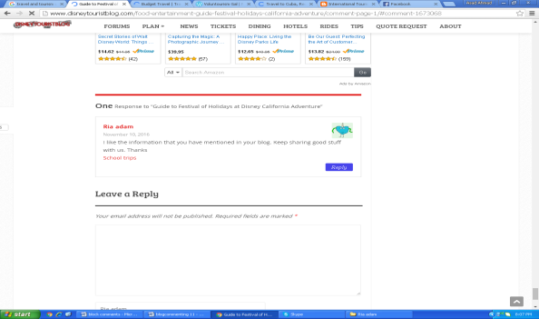
https://voluntourismgal.wordpress.com/2012/08/27/two-great-guides-from-daniela-papi/#comment-10587 | 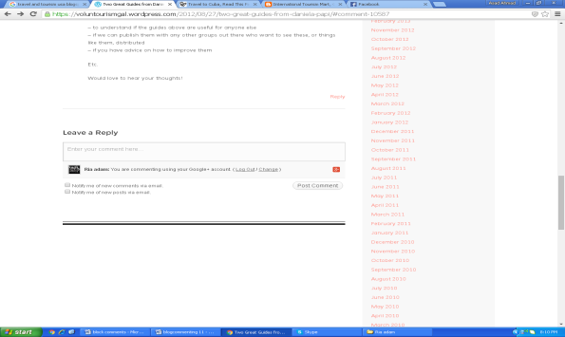
http://courtneyscott.tv/travel-cuba-read-first/#comment-2271 | 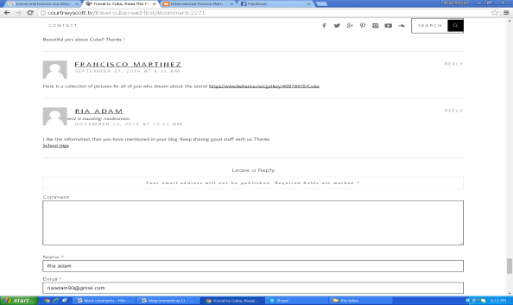
https://internationaltourismmart.blogspot.com/2012/12/paradise-unexplored-north-east-india.html?showComment=1478790789193#c6143968766646389747 | 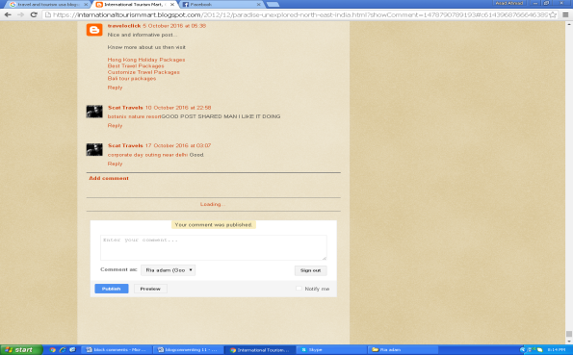
http://www.airlinereporter.com/2012/06/how-to-travel-to-dubai/#comment-3952742 | 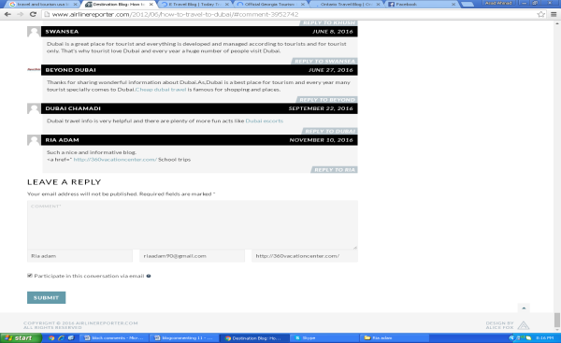
https://www.holidaylettings.co.uk/blog/top-20-budget-travel-bloggers-of-2015/#comment-82779 | 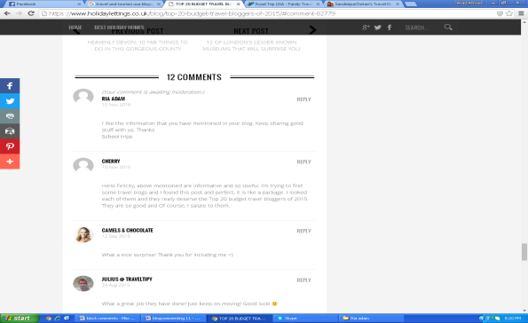
http://sandeepachetan.com/dubai-city-like-no-other-my-picks/#comment-3567 | 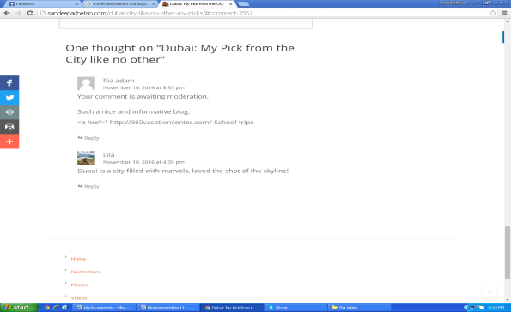
http://southernconeguidebooks.blogspot.com/2016/10/the-vikings-of-patagonia.html#comment-form | 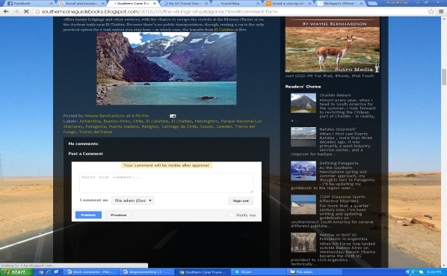
http://www.travelsupermarket.com/blog/avoid-a-visa-rip-off/#comment-166897 | 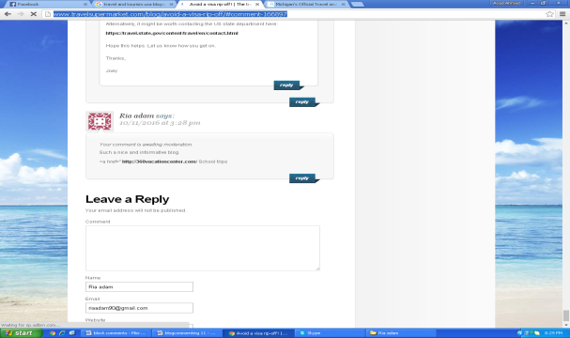
http://theincidentaltourist.com/post/152464111782/family-fun-on-the-shores-of-the-zambezi-avani#disqus_thread | 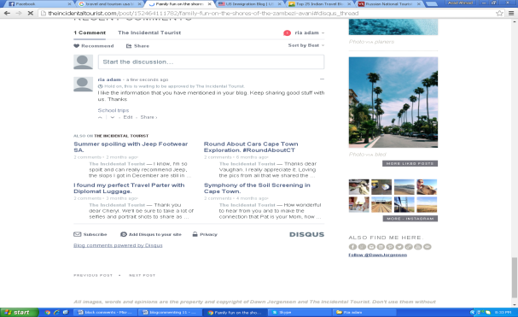
https://www.visitrussia.org.uk/blog/ekaterinburg-where-east-meets-west/#comment-98898 | 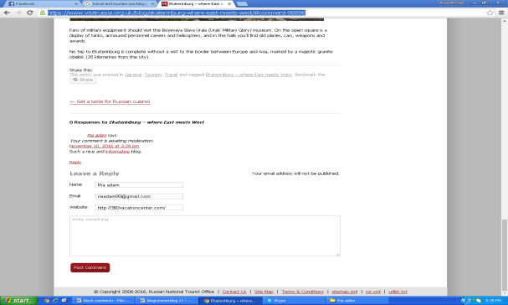
http://www.bestcubatravelguide.com/drugs/#disqus_thread | 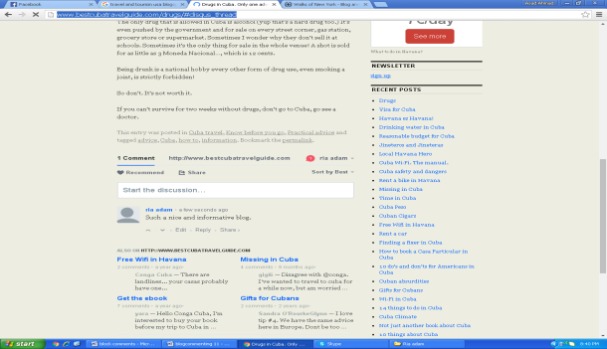
http://www.ask-aladdin.com/blog/how-to-get-egypt-travel-advices-that-can-help-during-stay-in-egypt/#comment-8282 | 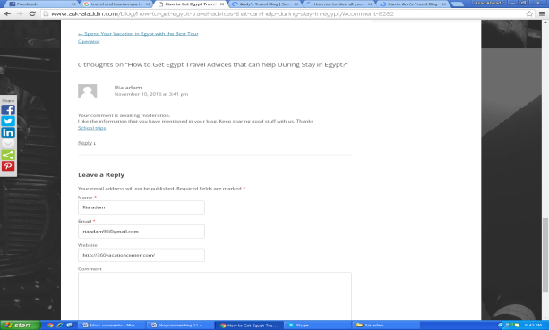
http://youngadventuress.com/2015/03/budget-travel-iceland.html/comment-page-1#comment-368024 | 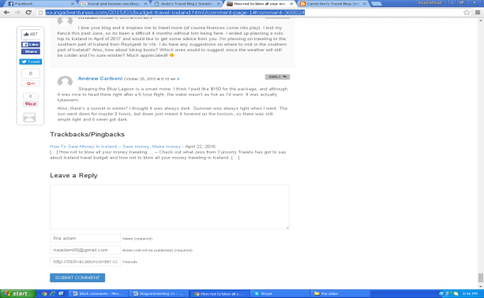
http://southernafricatravel.com/blog/the-cape-winelands/explore-sideways-the-wine-route-less-travelled/ | 